1. Source Code

v_footer.php -> application/views

v_header.php -> application/views

v_index.php -> application/views

v_about.php -> application/views

stylebuku.css -> assets/css

Web.php -> application/controllers

1. URL

<http://localhost/pustakabooking/web>

<http://localhost/pustakabooking/index.php/web/about>

1. Capture Output program

* Tampilan web home

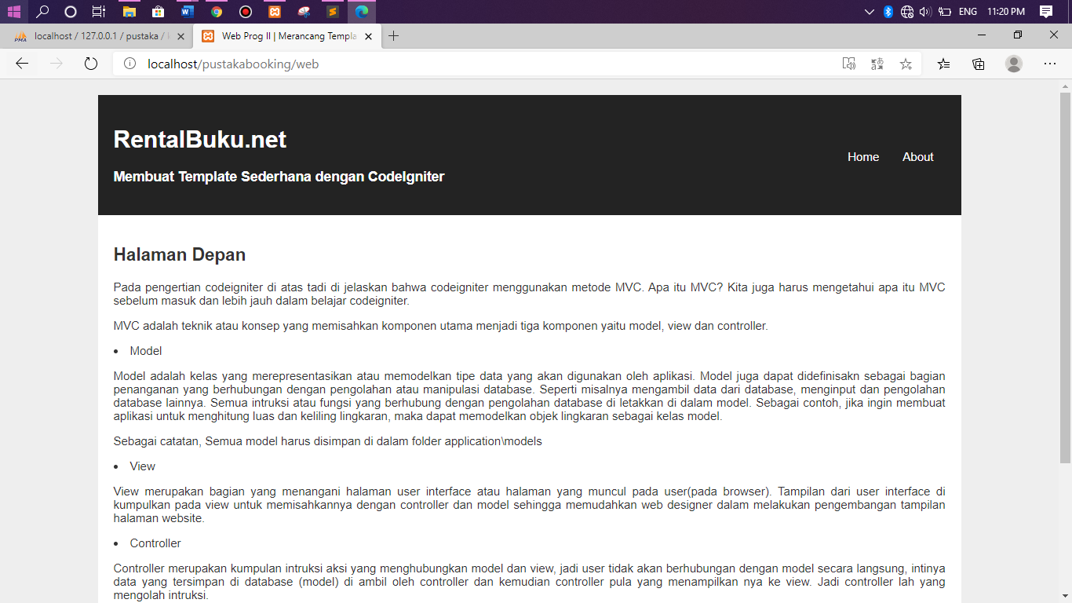

* Tampilan web about

